Human Biology – General Year 12 2019

## Task 2 – Unit 3

**Assessment Type:** Test

**Conditions**

Period allowed for completion of the task:

* 50 minutes in-class under test conditions

**Task Weighting :** 7.5% **Due Date:__________________**

**Name: ______________________________________________ Total : /52**

***MULTIPLE CHOICE SECTION [5 MARKS]***

1. 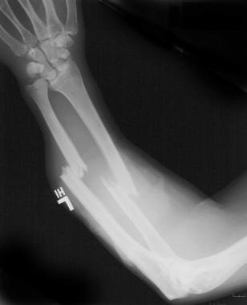The X-ray photo shows an injured arm. Which of the following statements is correct. The diagram shows:
2. A fracture to the ulna
3. A badly sprained wrist with several of the bones being displaced due to trauma
4. Damage to the radius and ulna bones of the forearm
5. The effect of an over-extension of muscles in the forearm causing ultra-rotation of the radius resulting in significant dislocation of the bones
6. 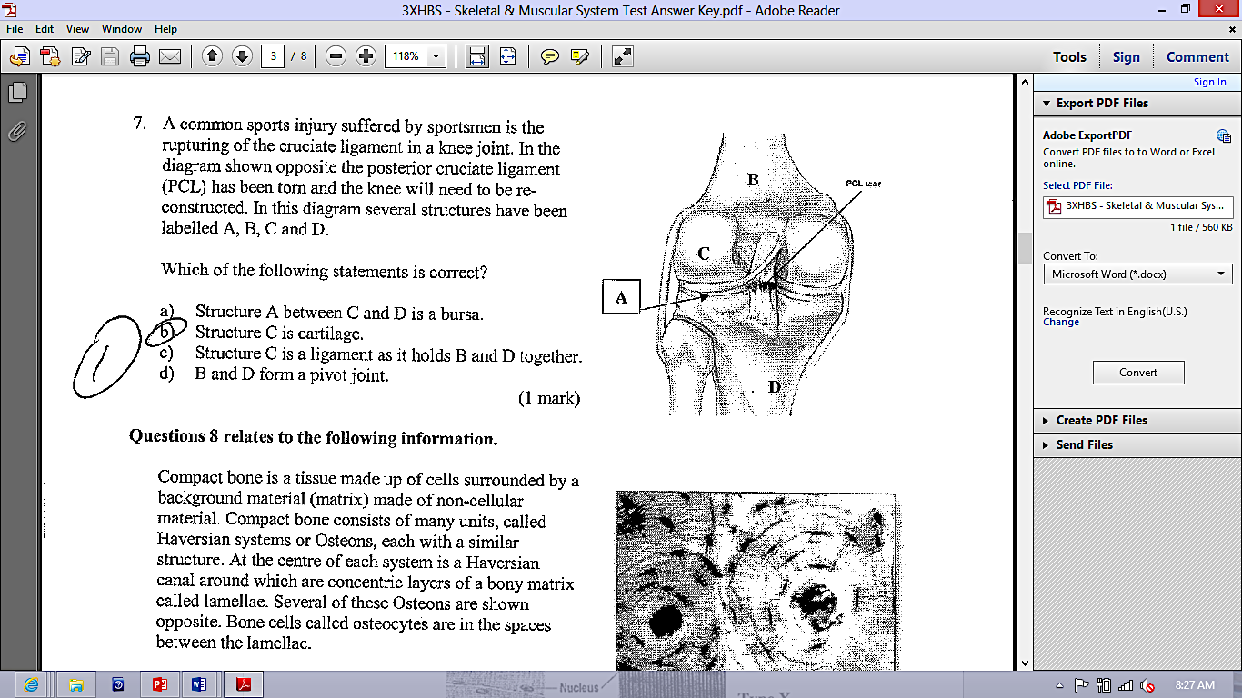A common sports injury suffered by sportsmen is the rupturing of the cruciate ligament in a knee joint. In the diagram, the posterior cruciate ligament (PCL) has been torn and the knee will need to be reconstructed.   
     
   In this diagram, several structures have been labelled A, B, C and D. Which of the following statements is correct ?
7. Structure A between C and D is a bursa
8. Structure C is articular cartilage
9. Structure C is a ligament as it holds B and D together
10. B and D from a pivot joint
11. How many bones are there in an adult human skeleton?
    1. 26
    2. 62
    3. 206
    4. 602
12. There are two types of bone marrow in long bones: red bone marrow and yellow bone marrow. Identify which statement is correct.
    1. Red bone marrow is found in the diaphysis whilst yellow bone marrow is found in the epiphysis of a long bone.
    2. Red bone marrow is where osteoclasts are stored and yellow bone marrow is where osteoblasts are stored.
    3. Red bone marrow is found in the epiphyses of the bone where blood cells are created. The cavity in the diaphysis is used as fat storage as bone marrow.
    4. Red bone marrow allows nutrients to pass into cartilage as it hasn’t got its own blood supply and yellow bone marrow is where the nervous system enters bones.
13. When the skeleton is first developing, it is initially made of cartilage. This cartilage then turns to bone in a process called ossification. In a 4-year-old, the only cartilage remaining in a long bone can be found:
    1. Covering the surface of the epiphysis
    2. At the epiphysial plate and covering the surface of the epiphysis
    3. In the medullary cavity
    4. Throughout the entire diaphysis

***SHORT ANSWER SECTION [47 MARKS]***

1. Describe the importance of the skeleton in the human body [5 marks]

__________________________________________________________________________________________________________________________________________________________________________________________________________________________________________________________________

__________________________________________________________________________________________________________________________________________________________________________________________________________________________________________________________________

__________________________________________________________________________________________________________________________________________________________________________________________________________________________________________________________________

__________________________________________________________________________________________________________________________________________________________________________________________________________________________________________________________________

__________________________________________________________________________________________________________________________________________________________________________________________________________________________________________________________________

__________________________________________________________________________________________________________________________________________________________________________________________________________________________________________________________________

1. Look at the human skeleton below.

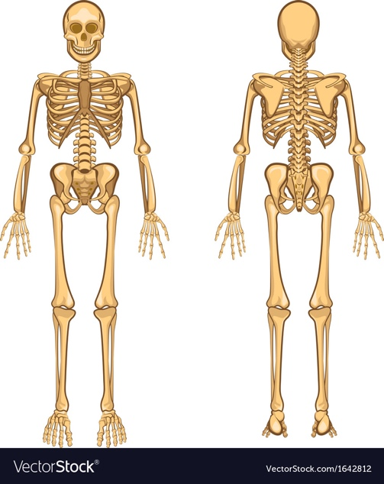

a

b

c

1. identify the following bones: [3 marks]
2. Using a pencil or texta, colour the axial skeleton [1 mark]
3. Label one example of a long bone, a short bone and an irregular bone [3 marks]
4. The ends of bones in a synovial joint never touch. If they did, moving would be very painful. What fluid in the joint helps keep the bones from touching? [1 mark]

_______________________________________________________________________________

1. A healthy lifestyle is essential during childhood and adolescence to build and maintain healthy bones. Explain why a diet with milk or dairy products and sensible sun exposure are important for improving bone health in children. [4 marks]

__________________________________________________________________________________________________________________________________________________________________________________________________________________________________________________________________

__________________________________________________________________________________________________________________________________________________________________________________________________________________________________________________________________

________________________________________________________________________________________________________________________________________________________________________________________________________________________________________________________________________________________________________________________________________________________

1. The body has several different types of joints, each with specific features and functions: Complete the following table as a summary of these different joints. [6 marks]

|  |  |  |
| --- | --- | --- |
| **LOCATION** | **JOINT TYPE** | **ONE MOVEMENT PRODUCED** |
| Elbow |  |  |
| Shoulder |  |  |
| Vertebrae |  |  |
| Skull |  |  |
| Neck |  |  |

1. Babies are born with roughly 300 bones. Describe why adults only have 206 bones. [3 marks]

__________________________________________________________________________________________________________________________________________________________________________________________________________________________________________________________________

______________________________________________________________________________________________________________________________________________________________________________________________________________________________________________________________________________________________________________________________________________________________________________________________________________________________________________

1. The diagram below shows a synovial joint in the human body. Name the structure and state the function of the structures indicated. [6 marks]

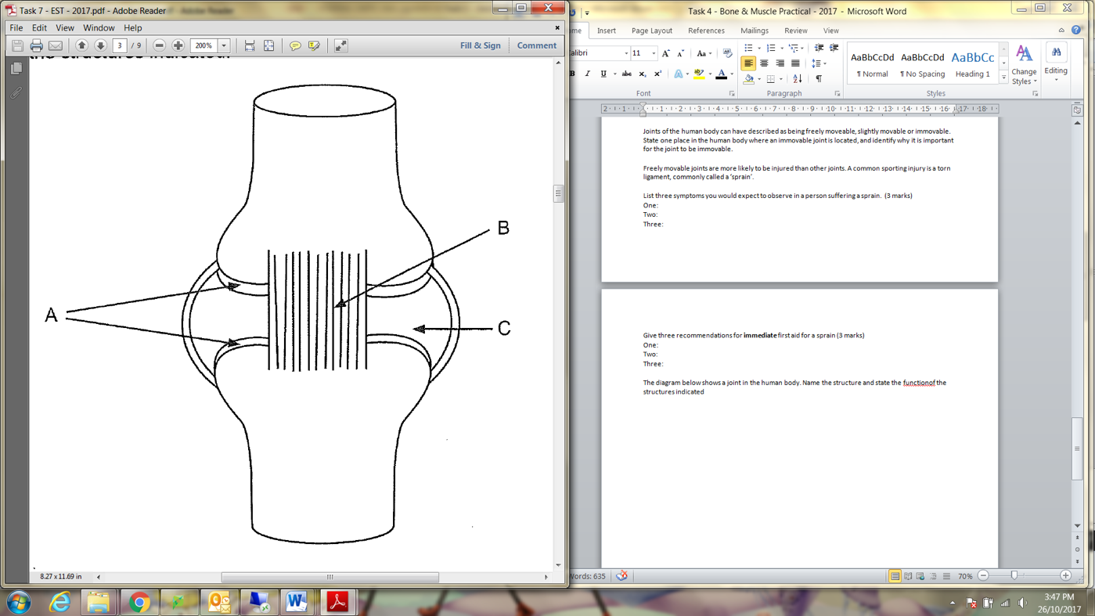

|  |  |
| --- | --- |
| **Name of Structure** | **Function** |
| A: |  |
| B: |  |
| C: |  |

1. During a game of soccer, Justin’s ankle became hyperextended. He felt pain, his ankle began to swell and he was unable to place weight on his foot. After two-weeks, his ankle had still not healed.
   1. State the name of the injury Justin sustained: ______________________________ [1 mark]
   2. Describe the structure that Justin had injured. [2 marks]

__________________________________________________________________________________________________________________________________________________

* 1. Explain why this body part will take longer to heal than muscle or bone [2marks]

____________________________________________________________________________________________________________________________________________________________________________________________________________________________________________________________________________________________________

* 1. In order for Justin’s ankle to heal more rapidly, he should have been given immediate first aid on the soccer field. State three recommendations for immediate first aid of this injury. [3 marks]

____________________________________________________________________________________________________________________________________________________________________________________________________________________________________________________________________________________________________

1. Observe the diagram of a long-bone below. Label the: [3 marks]
   1. Epiphyseal line
   2. Spongy bone
   3. Diaphysis

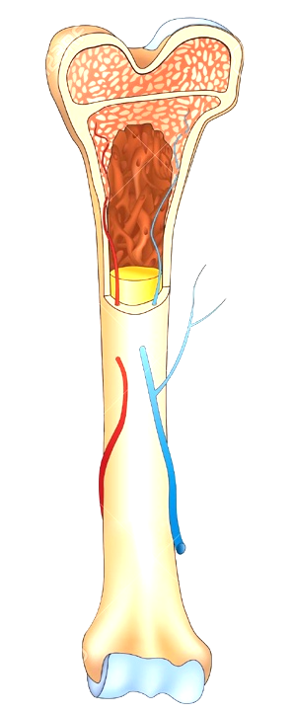

1. Describe the difference between compact bone and spongy bone in terms of structure and function [4 marks]

__________________________________________________________________________________________________________________________________________________________________________________________________________________________________________________________________________________________________________________________________________________________________________________________________________________________________________________________________________________________________________________________________________________________________________________________________________________________________________________________________________________________________________________________________________________________

**END OF TEST**